AI-ASSIGNMENT-6.4
Name : A.Yashwanth
Batch:42
Hall.no:2303A52432
Task 1: Student Performance Evaluation System:
Copilot: write a method to display student details
Copilot: write a method to check if marks are above class average
Prompt:
Generate a Python program with student name ,roll no,and marks add two methods
Two prints the student details and Performance through the overall class students to return
A message above or at or below performance through the loops.
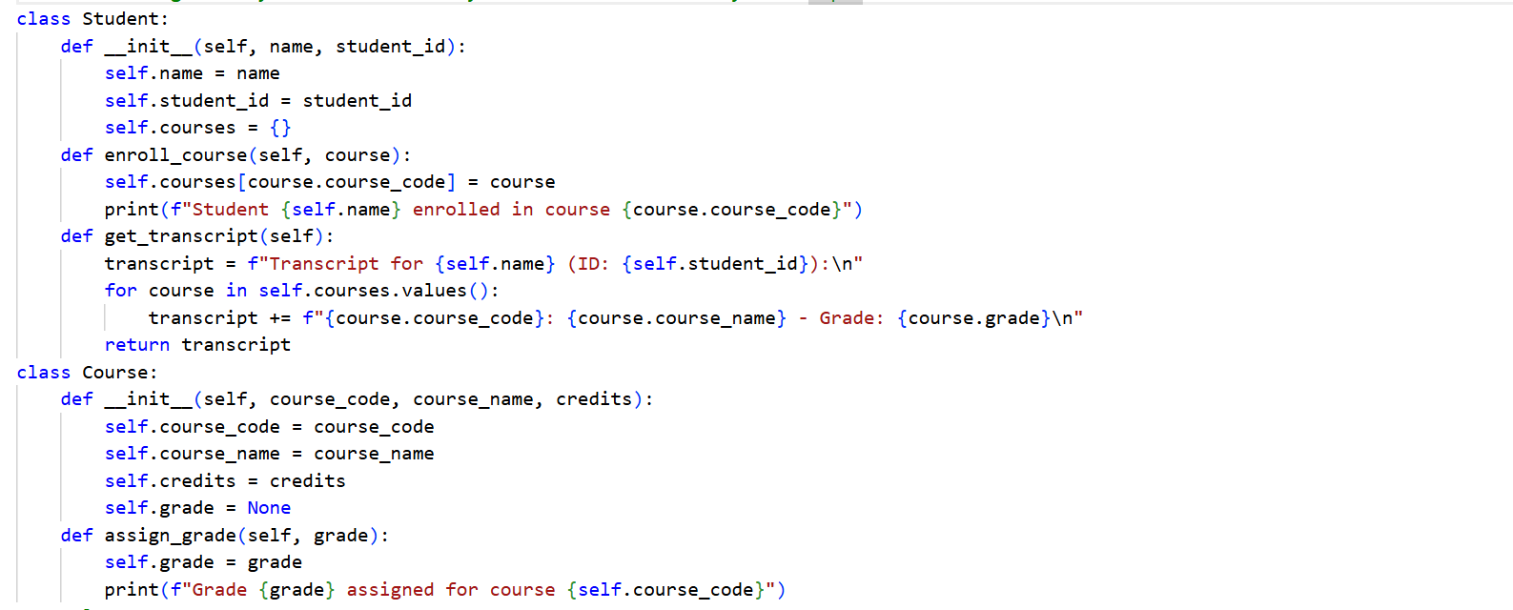
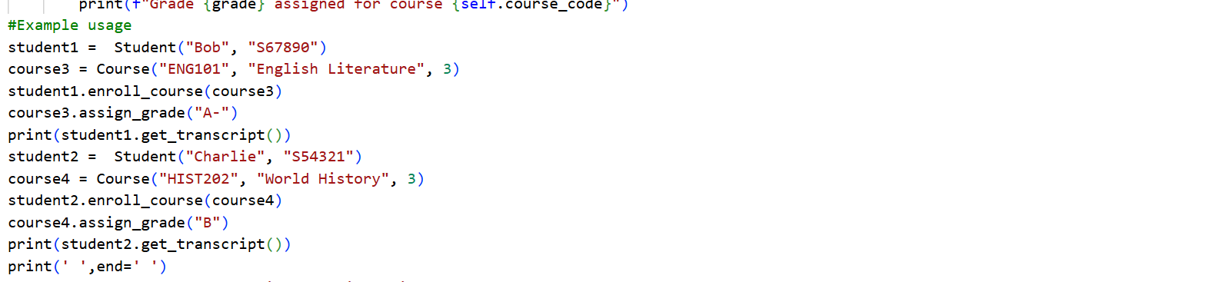OUTPUT:
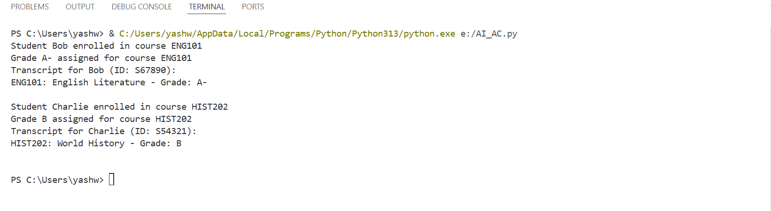
Task 2: Data Processing in a Monitoring System
Copilot: iterate through readings, check even numbers,
calculate their square and print the result
prompt:
Check if it's even using the modulus operator. If it is even, go ahead and calculate the square of that number. Then print it out nicely so I can see the original reading and its squared value. Oh, and if it's odd, just print a message saying we skipped it. Make sure everything looks clean and readable.
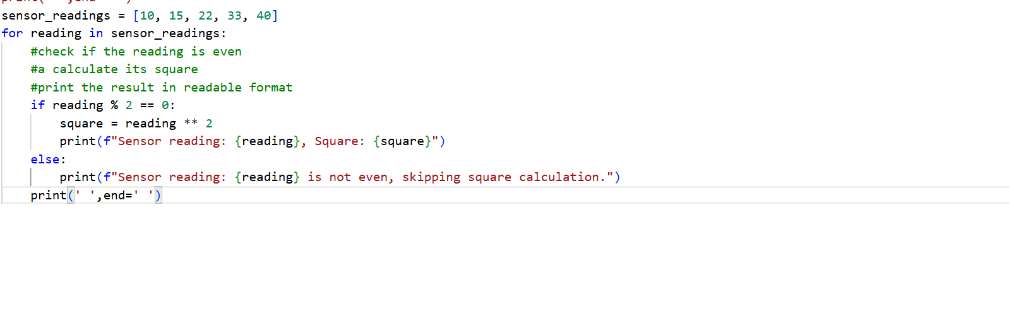
OUTPUT:
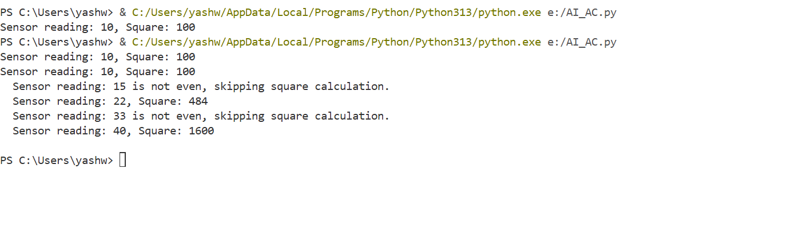Task 3: Banking Transaction Simulation:
Copilot: method to deposit money
Copilot: method to withdraw money with balance check
Prompt:
I'm building a Bank Account class here. It needs account holder and balance attributes. Can you help me create a deposit method that takes an amount, checks if it's positive, adds it to the balance using self, and prints a nice success message with the new balance.Also need a withdraw method that checks if there's enough money in the account before taking it out. If the balance is too low, show an error message saying insufficient funds. Use if-else for the balance check and work with self balance throughout.
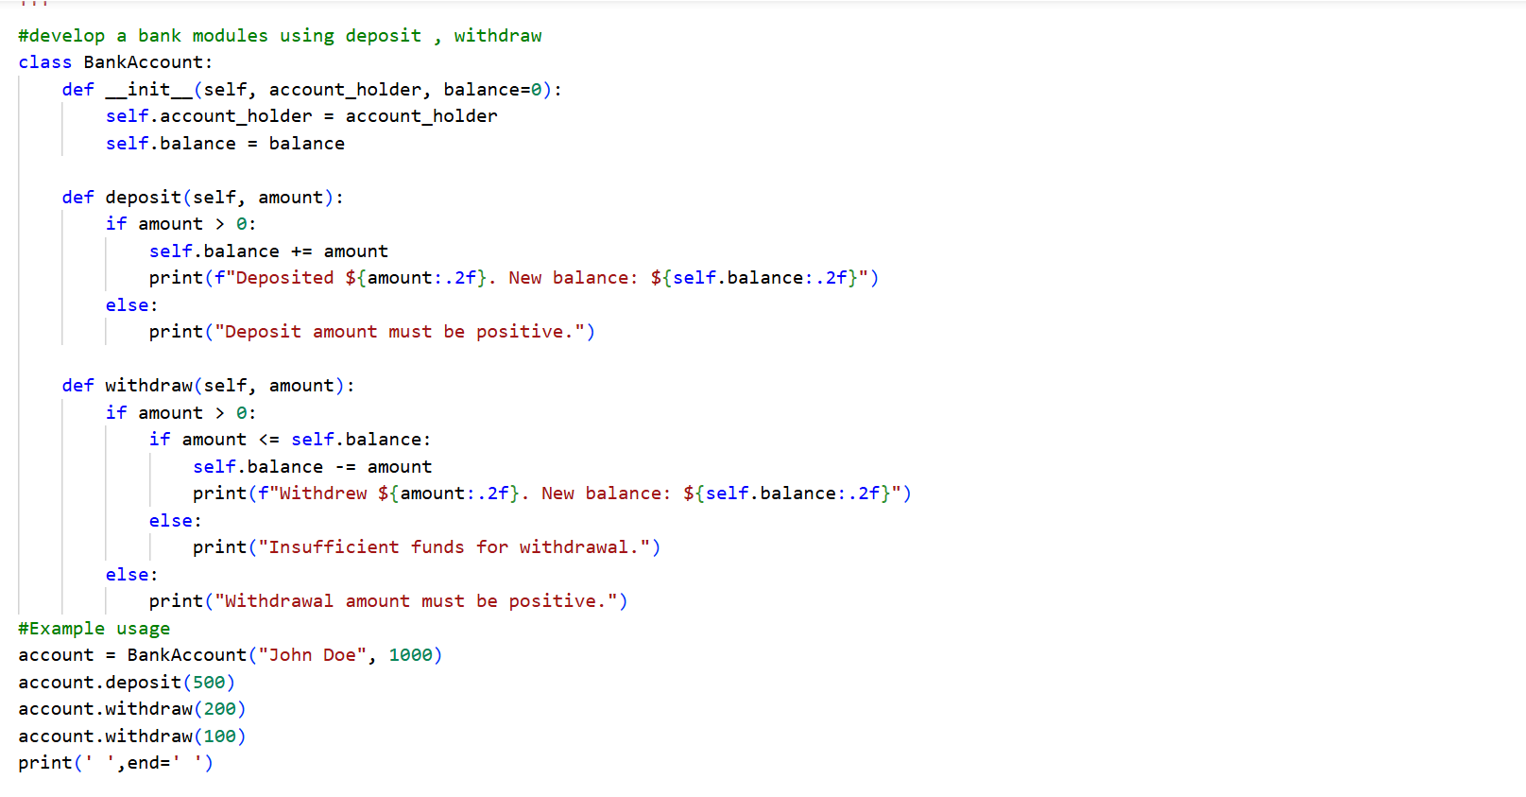
OUTPUT:
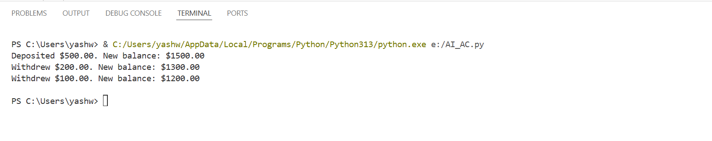
Task 4: Student Scholarship Eligibility Check:
Copilot: use while loop to print students scoring above 75
Prompt:
I need a while loop to go through this students list. Start with index at 0, then in each loop get the current student using students[index]. Check if their score is more than 75. If yes, print their name and say they're eligible for the scholarship. If not, print they're not eligible. Remember to increment the index each time and keep looping while index is less than the length of students. Also keep track of how many students are eligible so I can show a total count at the end. Format everything nicely
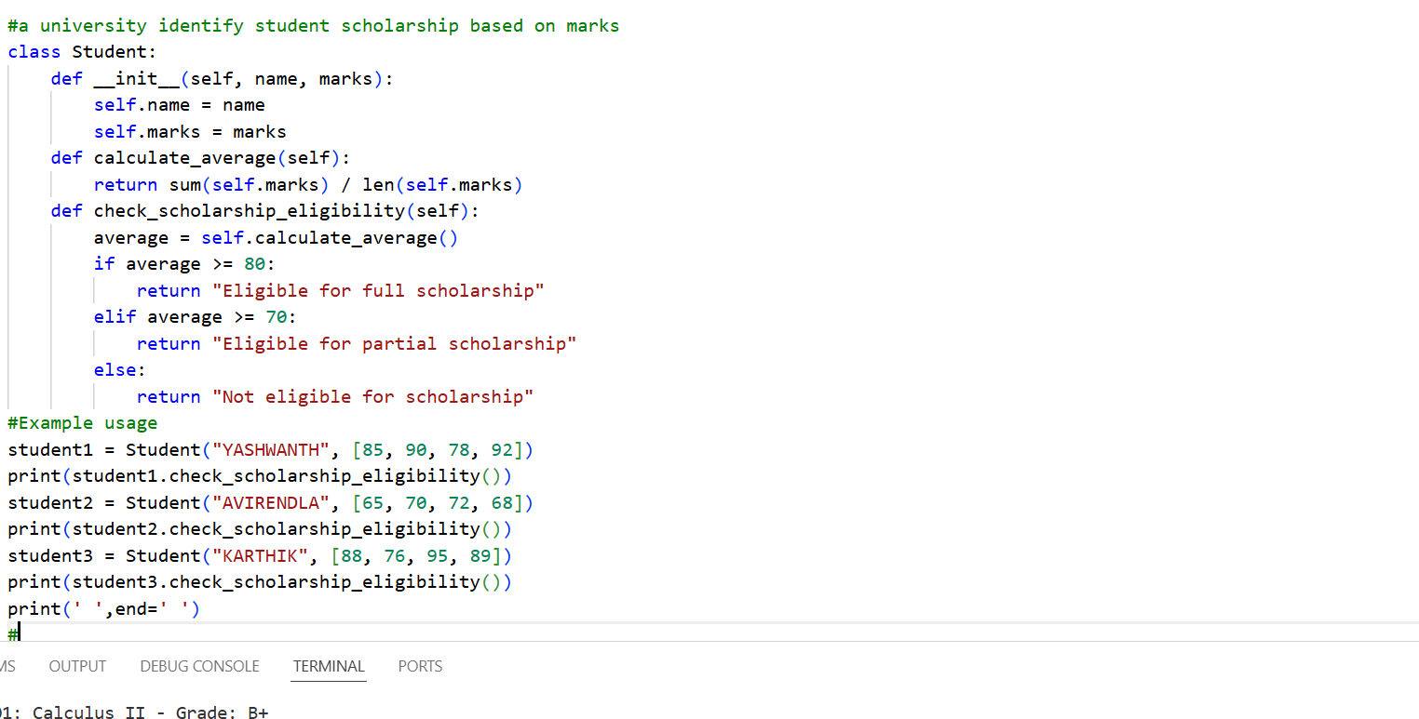

OUTPUT:
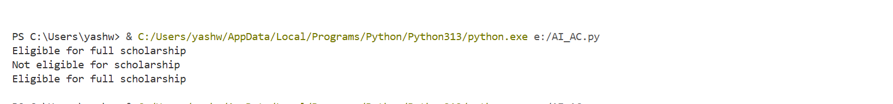
Task 5: Online Shopping Cart Module:
Copilot: add item method
Copilot: remove item method
Copilot: calculate total with discount
Prompt:
Create a Shopping cart class with an empty items list. Add three methods:
add item(name, price, quantity) to store an item dict and confirm addition;
remove item(name) to find and remove an item case-insensitively with success/error messages, calculate total() to print a receipt showing each item, compute subtotal, apply a 10% discount if subtotal > 100, and display subtotal, discount (if any), and final total formatted to 2 decimals.

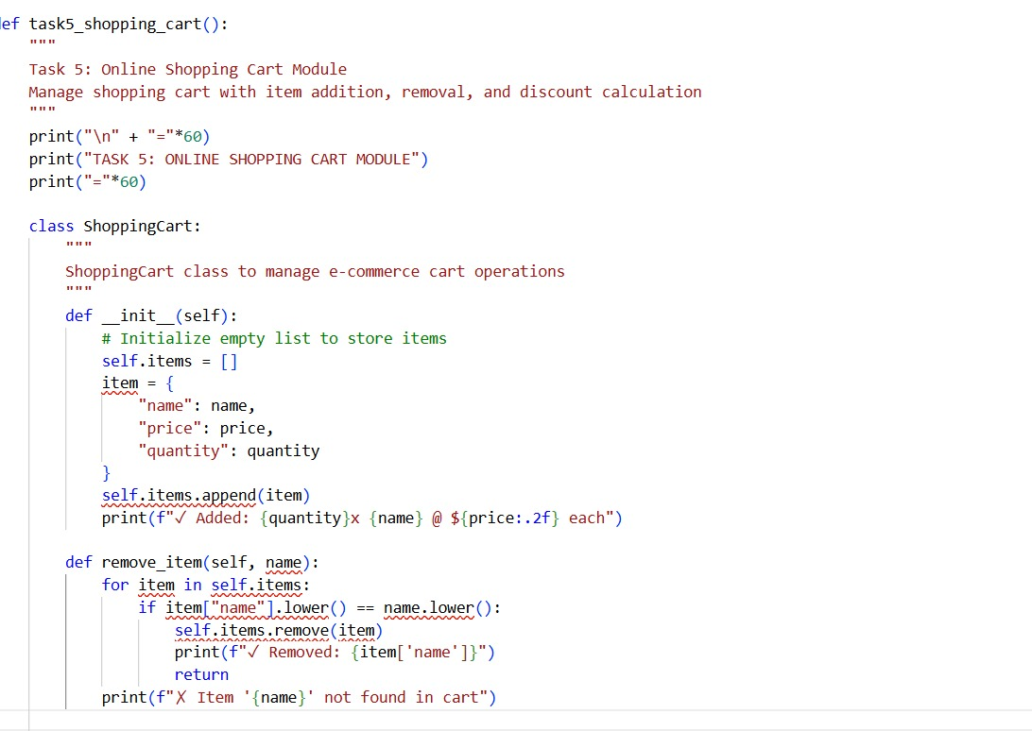
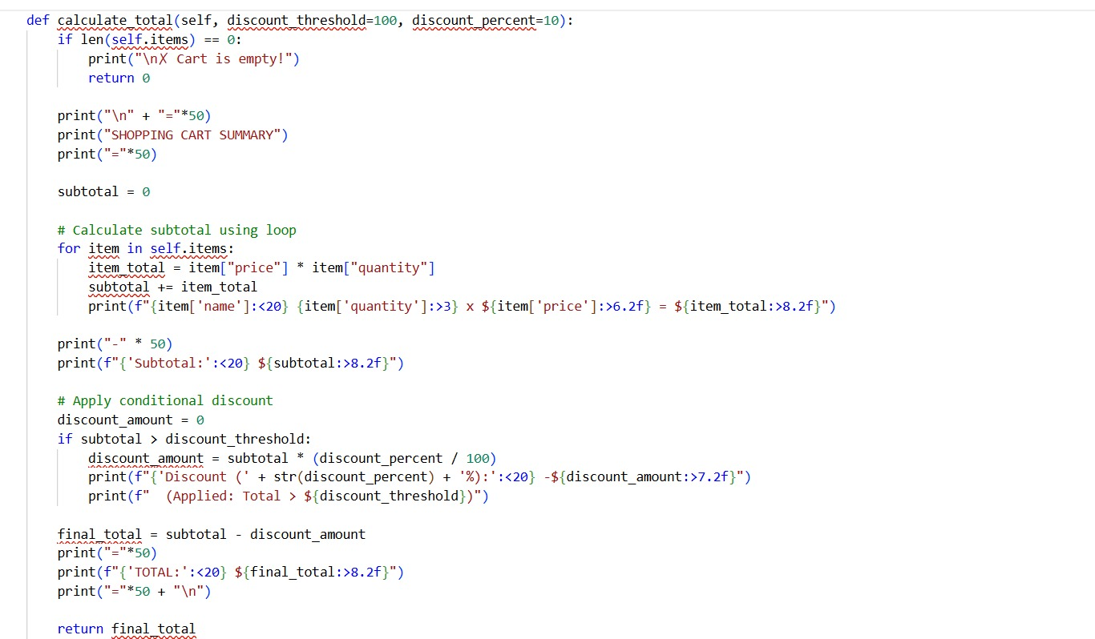
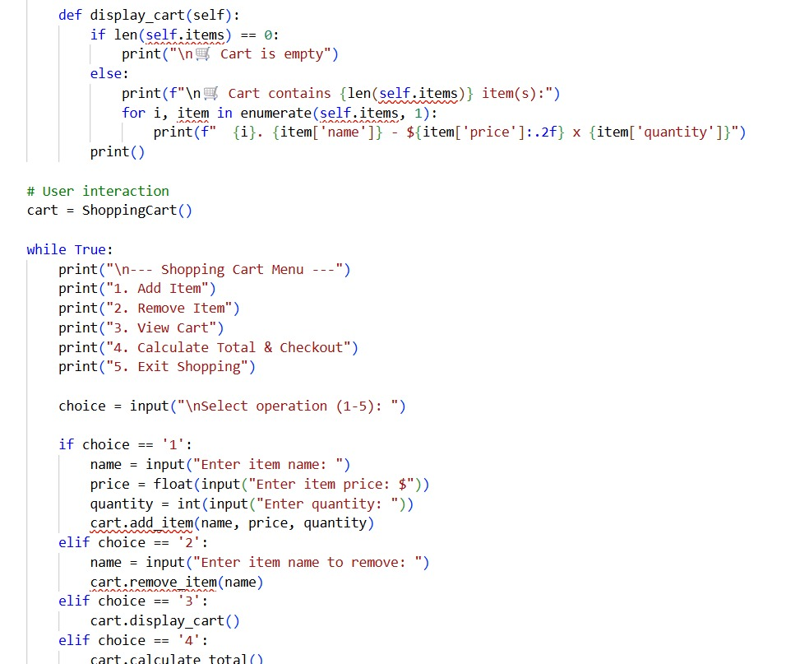
OUTPUT:
